GUDURU KRUTHI – 1WN24CS105
LAB1
MERGE SORT:
#include <stdio.h>
#include <stdlib.h>
#include <time.h>

#define MAX 50000

int arr[MAX], temp[MAX];

void merge(int low, int mid, int high)
{
int i = low;
int j = mid + 1;
int k = low;

while (i <= mid && j <= high)
{
if (arr[i] < arr[j])
temp[k++] = arr[i++];
else
temp[k++] = arr[j++];
}

while (i <= mid)
temp[k++] = arr[i++];

while (j <= high)
temp[k++] = arr[j++];

for (i = low; i <= high; i++)
arr[i] = temp[i];
}

void mergesort(int low, int high)
{
if (low < high)
{
int mid = (low + high) / 2;

mergesort(low, mid);

mergesort(mid + 1, high);

merge(low, mid, high);
}
}

int main()
{
int n, i;
clock_t start, end;
double time_taken;

srand(time(NULL));

printf("N\tTime Taken (seconds)\n");

for (n = 10000; n <= 50000; n += 10000)
{
for (i = 0; i < n; i++)
{
arr[i] = rand() % 50000;
}

start = clock();

mergesort(0, n - 1);

end = clock();

time_taken = (double)(end - start) / CLOCKS_PER_SEC;

printf("%d\t%.10f\n", n, time_taken);
}

return 0;
}

OUTPUT:
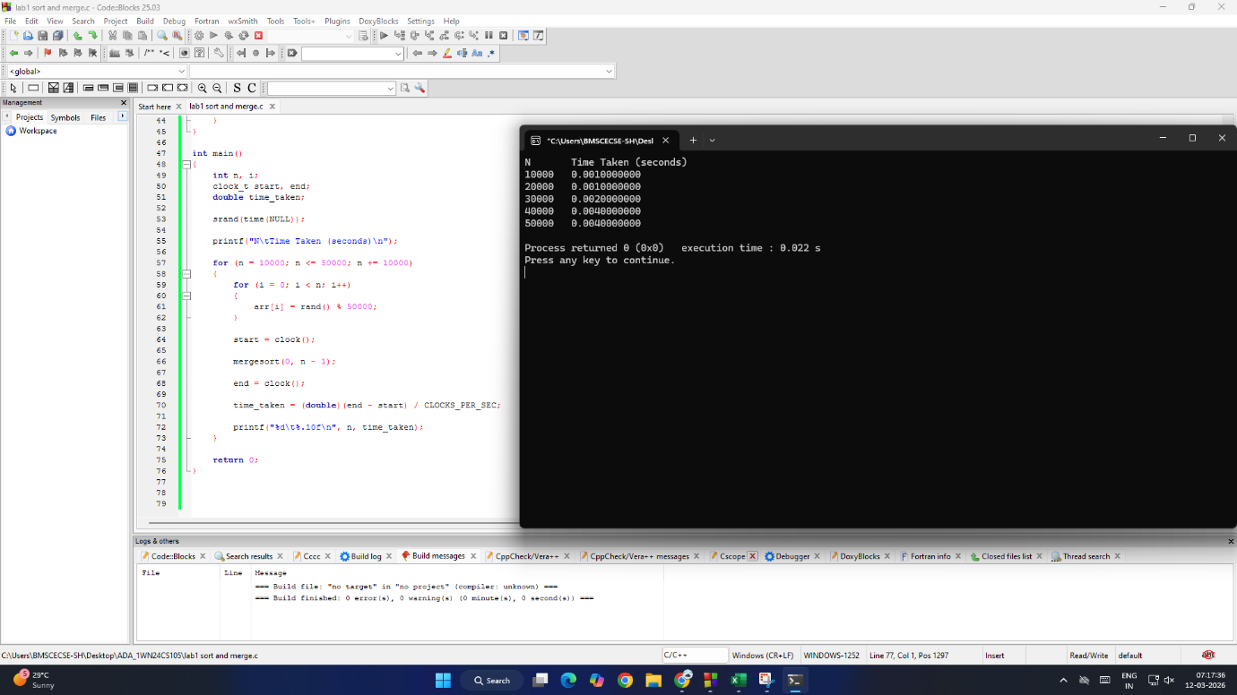
GRAPH:
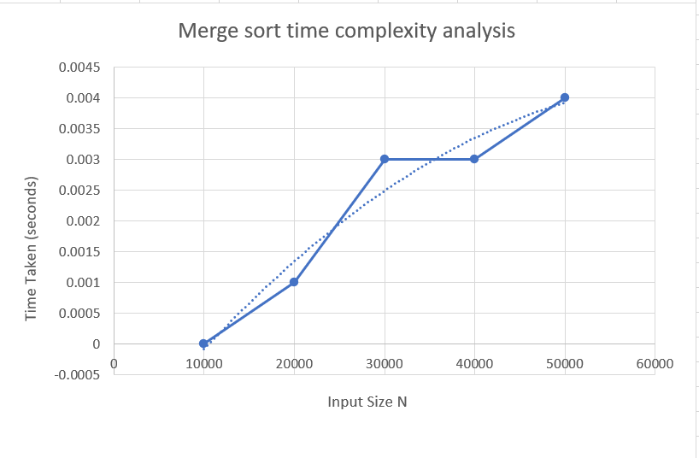

LAB 2
QUICK SORT:
#include <stdio.h>
#include <stdlib.h>
#include <time.h>

#define MAX 50000

int a[MAX];

void swap(int *a, int *b) {
int temp = *a;
*a = *b;
*b = temp;
}

int partition(int a[], int low, int high) {
int i = low;
int j = high + 1;
int pivot = a[low];

do {
do {
i++;
} while (i <= high && a[i] <= pivot);

do {
j--;
} while (a[j] > pivot);

if (i < j)
swap(&a[i], &a[j]);

} while (i < j);

swap(&a[low], &a[j]);
return j;
}

void quickSort(int a[], int low, int high) {
if (low < high) {
int j = partition(a, low, high);
quickSort(a, low, j - 1);
quickSort(a, j + 1, high);
}
}

int main() {
int n, i;

printf("Enter number of elements: ");
scanf("%d", &n);

int arr[n];

printf("Enter elements:\n");
for (i = 0; i < n; i++) {
scanf("%d", &arr[i]);
}

clock_t start, end;
double time_taken;

start = clock();
quickSort(arr, 0, n - 1);
end = clock();

time_taken = (double)(end - start) / CLOCKS_PER_SEC;

printf("Sorted array:\n");
for (i = 0; i < n; i++) {
printf("%d ", arr[i]);
}

printf("\nTime taken for this input: %lf seconds\n\n", time_taken);

printf("N\tTime Taken (seconds)\n");

for (n = 10000; n <= 50000; n += 10000) {

for (i = 0; i < n; i++) {
a[i] = rand() % 10000;
}

start = clock();
quickSort(a, 0, n - 1);
end = clock();

time_taken = (double)(end - start) / CLOCKS_PER_SEC;

printf("%d\t%lf\n", n, time_taken);
}

return 0;
}
OUTPUT:
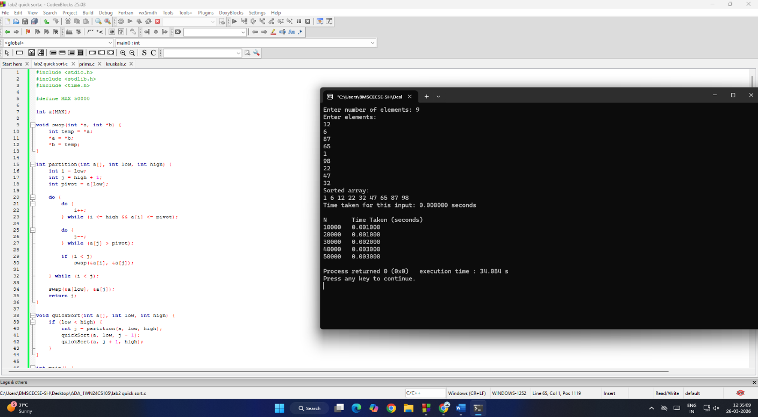
GRAPH:
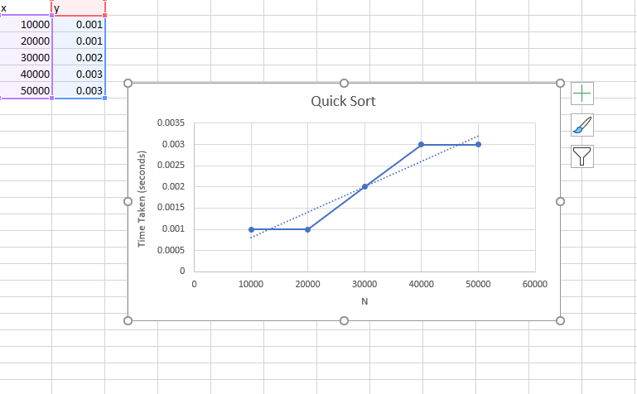

LAB 3
PRIMS ALGORITHM:
#include <stdio.h>
#define MAX 10
#define INF 9999

int main() {
int n, cost[MAX][MAX], visited[MAX] = {0};
int i, j, ne = 1;
int min, mincost = 0;
int a = 0, b = 0;
printf("Enter number of vertices: ");
scanf("%d", &n);
printf("Enter the cost adjacency matrix:\n");
for(i = 0; i < n; i++) {
for(j = 0; j < n; j++) {
scanf("%d", &cost[i][j]);

if(cost[i][j] == 0)
cost[i][j] = INF;
}
}

visited[0] = 1;
printf("\nEdges in MST:\n");

while(ne < n) {
min = INF;

for(i = 0; i < n; i++) {
if(visited[i]) {
for(j = 0; j < n; j++) {
if(!visited[j] && cost[i][j] < min) {
min = cost[i][j];
a = i;
b = j;
}
}
}
}

printf("%d -> %d = %d\n", a, b, min);

visited[b] = 1;
mincost += min;
ne++;
}
printf("\nMinimum cost of spanning tree = %d\n", mincost);
return 0;
}
OUTPUT:
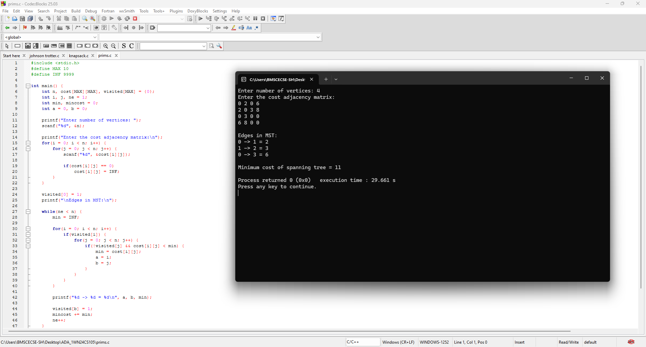
KRUSKAL’S ALGORITHM:
#include <stdio.h>

int parent[10];

int find(int i) {
while(parent[i])
i = parent[i];
return i;
}

int uni(int i, int j) {
if(i != j) {
parent[j] = i;
return 1;
}
return 0;
}

int main() {
int n, cost[10][10];
int i, j, min, mincost = 0;
int a, b, u, v, ne = 0;

printf("Enter number of vertices: ");
scanf("%d", &n);

printf("Enter cost matrix:\n");
for(i = 0; i < n; i++)
for(j = 0; j < n; j++) {
scanf("%d", &cost[i][j]);
if(cost[i][j] == 0)
cost[i][j] = 999;
}

printf("\nEdges selected:\n");

while(ne < n - 1) {
min = 999;

for(i = 0; i < n; i++)
for(j = 0; j < n; j++)
if(cost[i][j] < min) {
min = cost[i][j];
a = u = i;
b = v = j;
}

u = find(u);
v = find(v);

if(uni(u, v)) {
printf("%d - %d = %d\n", a, b, min);
mincost += min;
ne++;
}

cost[a][b] = cost[b][a] = 999;
}

printf("\nMinimum cost = %d\n", mincost);
}
OUTPUT:
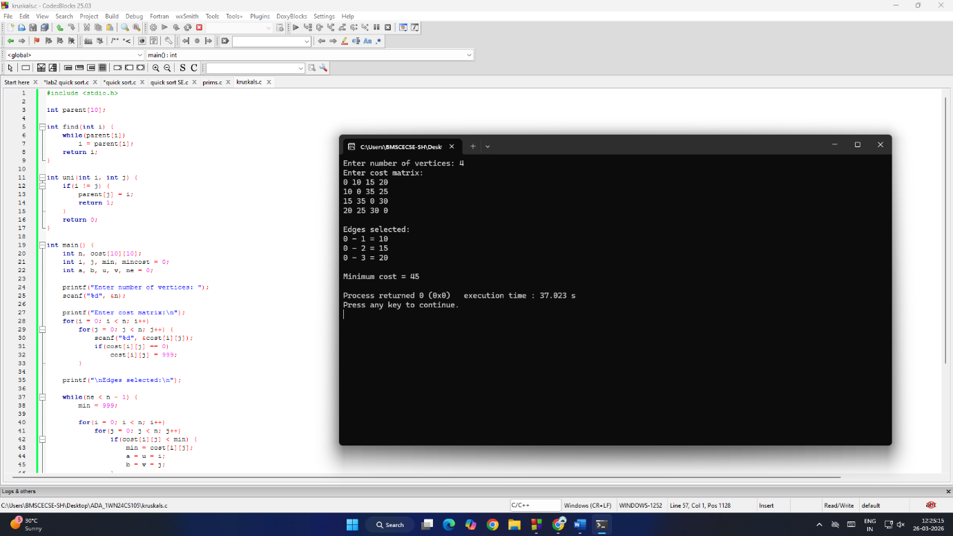

LAB 4
DIJKSTRAS ALGORITHM:
#include <stdio.h>

int main()
{
int i, j, n, v, k, min, u;
int c[20][20], s[20], d[20];

printf("\n Enter the no. of vertices : ");
scanf("%d", &n);

printf("\n Enter the cost adjacency matrix : ");
printf("\n Enter 999 for no edge\n");

for(i = 1; i <= n; i++)
{
for(j = 1; j <= n; j++)
{
scanf("%d", &c[i][j]);
}
}

printf("\n Enter the source vertex : ");
scanf("%d", &v);

for(i = 1; i <= n; i++)
{
s[i] = 0;
d[i] = c[v][i];
}

d[v] = 0;
s[v] = 1;

for(k = 2; k <= n; k++)
{
min = 999;

for(i = 1; i <= n; i++)
{
if((s[i] == 0) && (d[i] < min))
{
min = d[i];
u = i;
}
}

s[u] = 1;

for(i = 1; i <= n; i++)
{
if(s[i] == 0)
{
if(d[i] > d[u] + c[u][i])
{
d[i] = d[u] + c[u][i];
}
}
}
}

printf("\n The shortest distance from %d is:\n", v);

for(i = 1; i <= n; i++)
{
printf("\n %d --> %d = %d", v, i, d[i]);
}

return 0;
}
OUTPUT:
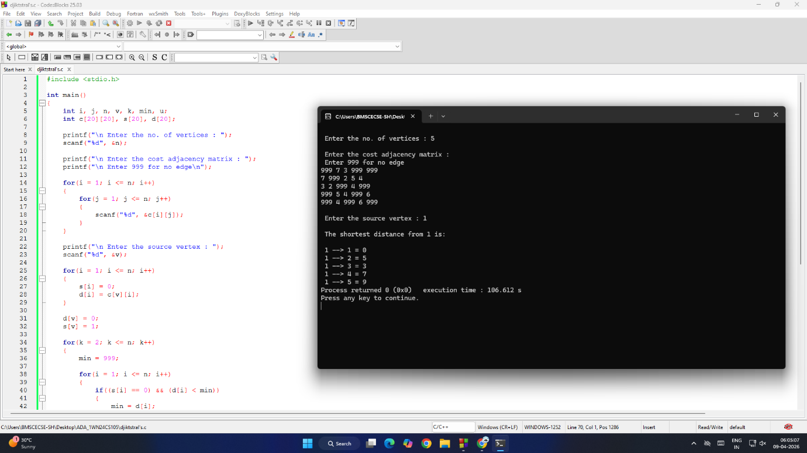

KNAPSACK ALGORITHM:
#include <stdio.h>

int main()
{
int i, j, n, capacity;
float weight[20], profit[20], ratio[20];
float totalProfit = 0.0;

printf("Enter number of items: ");
scanf("%d", &n);

printf("Enter weights and profits of each item:\n");
for(i = 0; i < n; i++)
{
printf("Item %d:\n", i + 1);
printf("Weight: ");
scanf("%f", &weight[i]);
printf("Profit: ");
scanf("%f", &profit[i]);

ratio[i] = profit[i] / weight[i];
}

printf("Enter capacity of knapsack: ");
scanf("%d", &capacity);

for(i = 0; i < n - 1; i++)
{
for(j = i + 1; j < n; j++)
{
if(ratio[i] < ratio[j])
{
float temp;

temp = ratio[i];
ratio[i] = ratio[j];
ratio[j] = temp;

temp = weight[i];
weight[i] = weight[j];
weight[j] = temp;

temp = profit[i];
profit[i] = profit[j];
profit[j] = temp;
}
}
}

for(i = 0; i < n; i++)
{
if(capacity >= weight[i])
{
capacity -= weight[i];
totalProfit += profit[i];
}
else
{
totalProfit += ratio[i] * capacity;
break;
}
}

printf("Maximum profit = %.2f\n", totalProfit);

return 0;
}
OUTPUT:
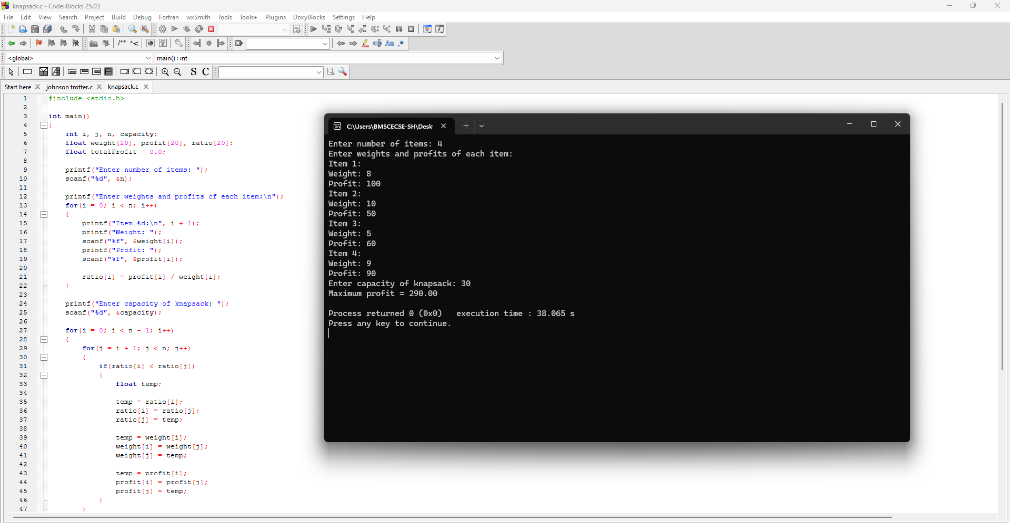

LAB 5
TOPO SORTING / TOPOLOGICAL SEQUENCE:
#include <stdio.h>

#define MAX 100

int main() {
int n;
int V[MAX][MAX];
int Indegree[MAX];
int visited[MAX];
int TP[MAX];
int tp_count = 0;

printf("Enter number of vertices: ");
scanf("%d", &n);

printf("Enter adjacency matrix:\n");
for (int i = 0; i < n; i++) {
for (int j = 0; j < n; j++) {
scanf("%d", &V[i][j]);
}
}

for (int i = 0; i < n; i++) {
Indegree[i] = 0;
for (int j = 0; j < n; j++) {
if (V[j][i] == 1) {
Indegree[i]++;
}
}
}

for (int i = 0; i < n; i++) {
visited[i] = 0;
}

while (1) {
int w = -1;

for (int i = 0; i < n; i++) {
if (visited[i] == 0 && Indegree[i] == 0) {
w = i;
break;
}
}

if (w == -1)
break;

TP[tp_count++] = w;
visited[w] = 1;

for (int i = 0; i < n; i++) {
if (V[w][i] == 1) {
Indegree[i]--;
}
}
}

if (tp_count < n) {
printf("No Topological Sequence (cycle detected)\n");
} else {
printf("Topological Sequence:\n");
for (int i = 0; i < tp_count; i++) {
printf("%d ", TP[i]);
}
printf("\n");
}

return 0;
}
OUTPUT:
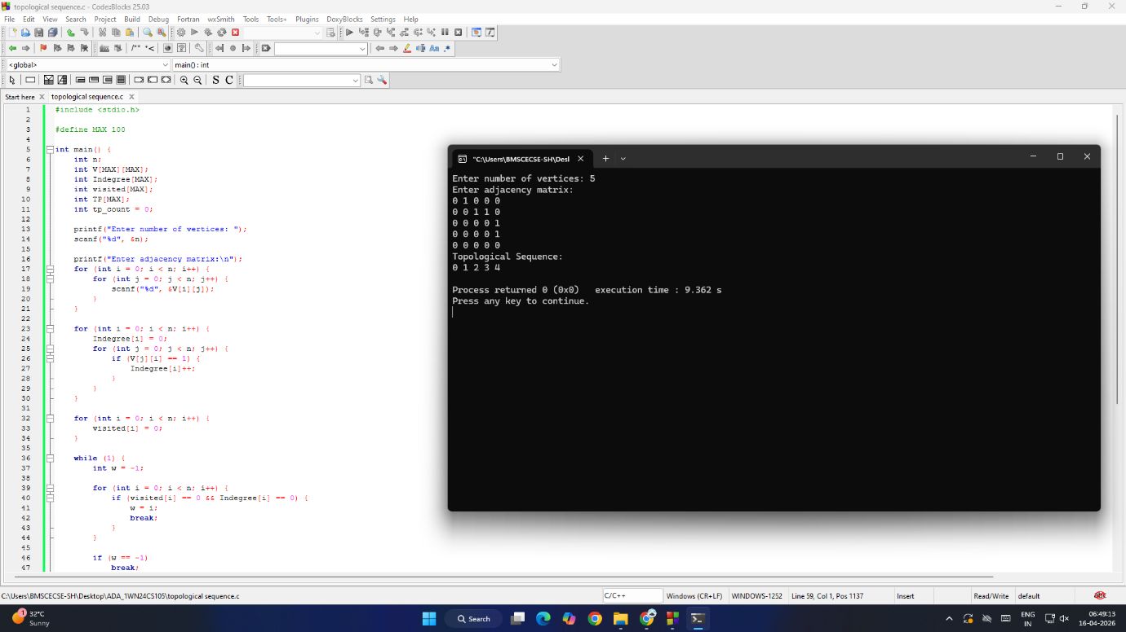

LAB 6
JOHNSON TROTTER ALGORITHM:
#include <stdio.h>
#include <stdbool.h>

#define LEFT_TO_RIGHT 1
#define RIGHT_TO_LEFT 0

void swap(int *a, int *b) {
int temp = *a;
*a = *b;
*b = temp;
}

int getMobile(int a[], int dir[], int n) {
int mobile = 0;

for (int i = 0; i < n; i++) {
if (dir[a[i] - 1] == RIGHT_TO_LEFT && i != 0) {
if (a[i] > a[i - 1] && a[i] > mobile)
mobile = a[i];
}
if (dir[a[i] - 1] == LEFT_TO_RIGHT && i != n - 1) {
if (a[i] > a[i + 1] && a[i] > mobile)
mobile = a[i];
}
}
return mobile;
}

int findPosition(int a[], int n, int mobile) {
for (int i = 0; i < n; i++) {
if (a[i] == mobile)
return i;
}
return -1;
}

void printPermutation(int n) {
int a[n];
int dir[n];

for (int i = 0; i < n; i++) {
a[i] = i + 1;
dir[i] = RIGHT_TO_LEFT;
}

for (int i = 0; i < n; i++)
printf("%d ", a[i]);
printf("\n");

while (1) {
int mobile = getMobile(a, dir, n);
if (mobile == 0)
break;
int pos = findPosition(a, n, mobile);
if (dir[mobile - 1] == RIGHT_TO_LEFT)
swap(&a[pos], &a[pos - 1]);
else
swap(&a[pos], &a[pos + 1]);
int newPos = findPosition(a, n, mobile);

for (int i = 0; i < n; i++) {
if (a[i] > mobile)
dir[a[i] - 1] = !dir[a[i] - 1];
}

for (int i = 0; i < n; i++)
printf("%d ", a[i]);
printf("\n");
}
}
int main() {
int n;
printf("Enter n:");
scanf("%d",&n);
printPermutation(n);
return 0;
}

OUTPUT:
